

**Zenith Services Inc.**

**e-Trademine.com**

**User Interface**

**Document: User Interface**

**Issued on :**

**Author : Om Nakka**

**Version : 1.0**

**Copyright**

ã 2014 Zenith Services Inc.

All rights reserved

The recipient receives this document on the condition that the recipient will keep the document confidential and will not use its contents in any form or by any means without the prior written permission of Zenith Services Inc. Moreover, the recipient is not authorised to place this document at the disposal of any third party without the prior written permission of Zenith Services Inc.

If such permission is granted, it will be subject to the condition that the recipient ensures that any recipient of this document, or information contained therein, is held responsible to Zenith Services Inc. for the confidentiality of that information.

Zenith Services Inc. undertakes to treat all information provided by the recipient as confidential.

The General Terms of Zenith Services Inc. apply to this document.

e-Trademine

All trademarks used in this document remain the property of their rightful owners.

**Change of Record**

|  |  |  |  |
| --- | --- | --- | --- |
| Date | Author | Release | Change description |
| 20-Mar-2009 | Om Nakka | 1.0 | Initial document |
|  |  |  |  |
|  |  |  |  |
|  |  |  |  |
|  |  |  |  |
|  |  |  |  |
|  |  |  |  |

**Distribution**

|  |  |  |  |
| --- | --- | --- | --- |
| No | Name | Organization | Comments |
| 1 | Om Nakka | Zenith Services Inc. |  |
| 2 | Udayasri Addala | Zenith Services Inc. |  |
|  |  |  |  |
|  |  |  |  |
|  |  |  |  |
|  |  |  |  |
|  |  |  |  |

**Table of Contents**

|  |  |
| --- | --- |
| Content | Page No |
| Overview | 7 |
| Foreign Exchange Option  History of Forex  FxSpot/Forward  FxSwap  FxOption  FxFuture  FxNDF | 13  13  18  22  26  29  33 |
| Trade & Real-Time Analysis  Trade Blotter  Risk Blotter | 39  39  41 |
| Risk Reports  Scenario Analysis | 42  43 |
| Portfolio Analysis  P/L Analysis | 44  45 |
| Cash Flow Analysis | 46 |
| Compliance Reports | 48 |
| Equities Option  Stocks  Options | 50  51  52 |
| IR Derivatives  IRSwap  IRSwaption  FRA | 53  54  57  59 |
| Commodities | 61 |
| Credit Derivatives  Credit Default Swap | 64  65 |
| Market Data  Currencies | 66  68 |
| Securities  Bonds | 68  70 |

**List of Figures**

|  |  |  |
| --- | --- | --- |
| S.No | Figure | Page No |
| 1 | Menu Layout | 9 |
| 2 | Home Screen | 10 |
| 3 | About Us Screen | 10 |
| 4 | Contact Us Screen | 11 |
| 5 | Register page | 11 |
| 6 | Login Page | 12 |
| 7 | Trade Options Slider | 12 |
| 8 | Forex Options | 18 |
| 9 | FX Spot/Forward-Economic Details | 19 |
| 10 | FX Spot/Forward-Cash Flow Details | 20 |
| 11 | FX Spot/Forward-Risk Details | 20 |
| 12 | FX Spot/Forward-Market Data | 21 |
| 13 | FX Spot/Forward-Non Economic Details | 21 |
| 14 | FX Spot/Forward-Fee Details | 22 |
| 15 | FX Swap-Economic Details | 23 |
| 16 | FX Swap-Cash Flow Details | 24 |
| 17 | FX Swap-Risk Details | 24 |
| 18 | Fx Swap-Market Data | 25 |
| 19 | FX Swap-Non Economic Details | 25 |
| 20 | FX Swap-Fee Details | 26 |
| 21 | FX Option-Economic Details | 27 |
| 22 | FX Option-Risk Details | 28 |
| 23 | FX Option-Market Data | 28 |
| 24 | FX Option-Non Economic Details | 29 |
| 25 | FX Option-Fee Details | 29 |
| 26 | FX Future-Economic Details | 30 |
| 27 | FX Future-Cash Flow Details | 31 |
| 28 | FX Future-Risk Details | 31 |
| 29 | FX Future-Market Data | 32 |
| 30 | FX Future-Non Economic Details | 32 |
| 31 | FX Future-Fee Details | 33 |
| 32 | FX NDF-Economic Details | 36 |
| 33 | FX NDF-Cash Flow Details | 36 |
| 34 | FX NDF-Risk Details | 37 |
| 35 | FX NDF-Market Data | 37 |
| 36 | FX NDF-Non Economic Details | 38 |
| 37 | FX NDF-Fee Details | 38 |
| 38 | Trade and Risk Options | 39 |
| 39 | Trade Blotter | 40 |
| 40 | Risk Blotter | 41 |
| 41 | Risk Report Options | 43 |
| 42 | Scenario Analysis | 44 |
| 43 | Portfolio Analysis Options | 45 |
| 44 | P/L Analysis | 46 |
| 45 | Cash Flow Analysis Options | 47 |
| 46 | Cash Flow Analysis | 48 |
| 47 | Compliance Report Options | 49 |
| 48 | Compliance Reports | 49 |
| 49 | Equities Options | 51 |
| 50 | Stocks View | 52 |
| 51 | Option View | 53 |
| 52 | IR Derivatives Options | 54 |
| 53 | IR Swap-Economic Details | 55 |
| 54 | IR Swap-Cash Flow Details | 56 |
| 55 | IR Swap-Non Economic Details | 56 |
| 56 | IR Swap-Fee Details | 57 |
| 57 | IR Swaption-Economic Details | 58 |
| 58 | IR Swaption-Non Economic Details | 58 |
| 59 | IR Swaption-Fee Details | 59 |
| 60 | FRA-Economic Details | 60 |
| 61 | FRA-Cash Flow Details | 60 |
| 62 | FRA-Non Economic Details | 61 |
| 63 | FRA-Fee Details | 61 |
| 63 | CommoditiesOptions | 65 |
| 64 | Market Data Options | 68 |
| 65 | Currencies | 68 |
| 66 | Securities Options | 70 |
| 67 | Bonds | 71 |

**OVERVIEW:**

e-Trademine.com is an electronic trading and analytical system that allows clients to e-trade any listed instruments, options and provides real-time analysis of the profit and loss analysis of underlying portfolio analysis. It also allows clients do the research and analyze performance of underlying instruments based on historical and real-time data. This application has several integrated modules such real-time streaming of market prices, option pricing and analysis using market standard models such as Black-Scholes model, charting module for real-time and historical analysis.

The Real-time Streaming Tool is a core feature of the e-Trademine application that basically lets users track their favorite stocks simultaneously as the market moves (One minute behind the market moves). It is used for displaying real-time quotes for listed company symbols grouped by the sector per user.

The Option analysis is one of the core features of the e-Trademine application, and will enable the user to quickly and intuitively analyze the attractiveness of particular options contracts, and perform sensitivity and scenario analysis.

The Charting is another of the core tools on the e-Trademine application, and will be used for graphing historical and real-time data for one or more companies

The Research Module is also one of the available tools on the e-Trademine application, and will be used for displaying and comparing historical and projected fundamental data for one or more organizations.

The Portfolio Module allows the user to track and analyze his/her investments in real-time. The portfolio is designed to handle multi-currency equity products such as stocks, options and mutual funds. In future enhancement versions will include fixed income products capabilities.

e-Trademine.com with integrated features will be unique in the market and application rich functionality and its scalability allows investors and traders to do active trading and hedging portfolio based on performance of underlying stocks and options. These unique features allows us convince potential customers to use for their daily trading, market analysis and profit and loss.

Trading Module: This allows client to execute trade with selected exchange and confirmed trade.

News Module: Allows client to scan all the financial and political news across the globe.

Features:

* Pre and Post trade analysis of Foreign Exchange Products
* Real-time Position and Risk viewer
* P&L Analysis and Cashflow Analysis
* Currency and Future Equivalent exposure report by different maturity buckets
* Trade Entry for FX Spot/Forward , NDF, FX Swap,FX Options,FX Spot Future
* Real-time Monitoring tool spot rates

Benefits:

|  |
| --- |
| * Set multiple watch-lists |
| * Create tab-wise access to watch-list |
| * View placed order and trade confirmation |
| * Select indices/sectors or business groups |
| * Trade long contracts |
| * Facility to sell from existing stocks |
| * Limits, Positions tabs available in the Risk Report |
| * View changing profit and loss |
| * Fast and convenient User Interface |
| * Customizable User Interface |
| * View live Market Depth |
| * Predefined watch-list to create personalized watch-list |

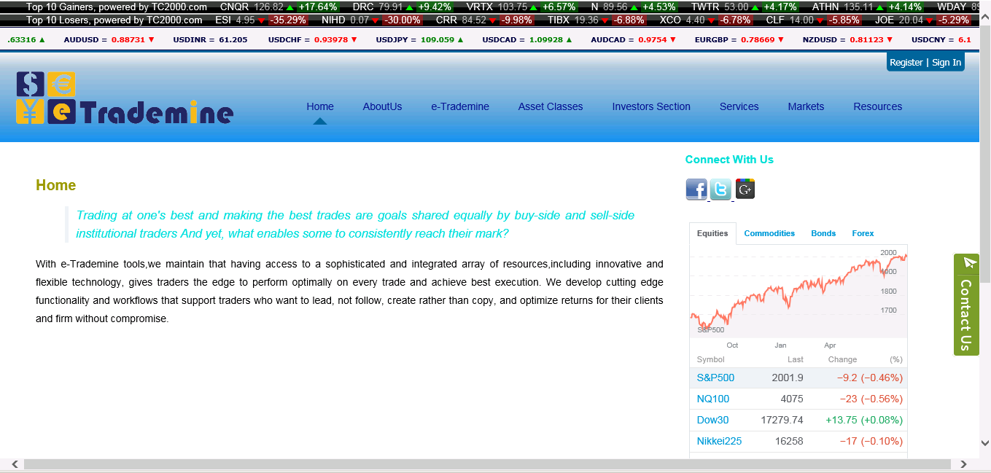

Figure 1.1: Menu Layout

Ticker--Scrolling the current trading analysis data

Market Data—Displays the current market data

Ticker: Scrolls the present market data from the right side of the page to left side of the page. Authorized or unauthorized clients can view the current trading data, market top gainers, market top losers.

Menu Bar: The menu options are home, about us, contactus, products.

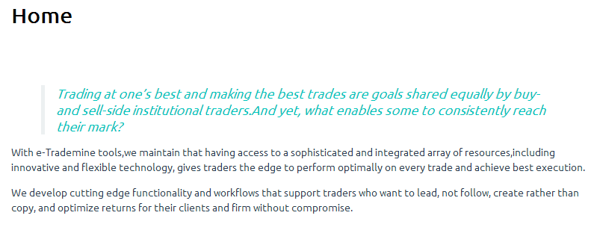

Figure 1.2: Home Screen

Home menu—describes about organization overview.

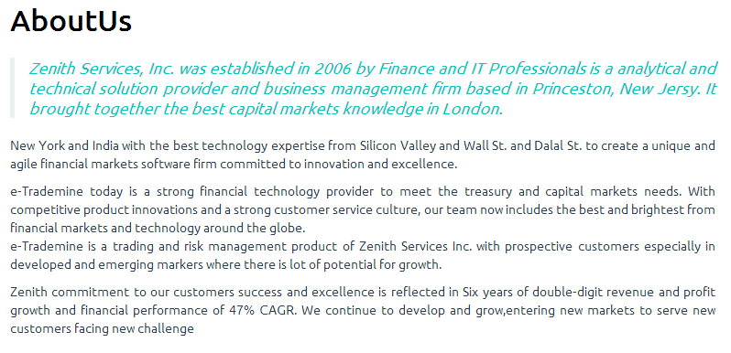

Figure 1.3: About us screen

About us menu—describes about the e-Trademine web project and its part of establishment, distinguishing the worthy features and tools

Contact us menu: Shows the contact details of the organization. To learn moreabouthow e-Trademine suite ofinnovativeproducts and services can help you visit our solutions page or contact page of our product specialists.

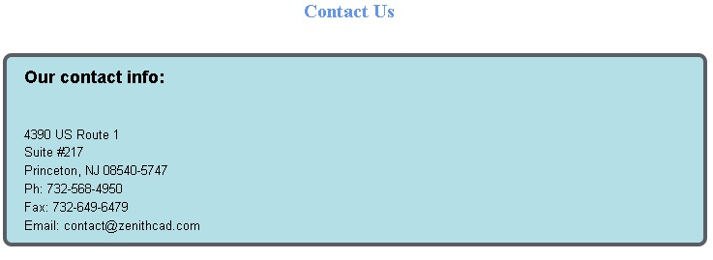

Figure 1.4: Contact us screen

Contact us menu: Shows the contact details of the organization. To learn moreabouthow e-Trademine suite ofinnovativeproducts and services can help you visit our solutions page or contact page of our product specialists.

Register and login for clients to interact with the trading data.

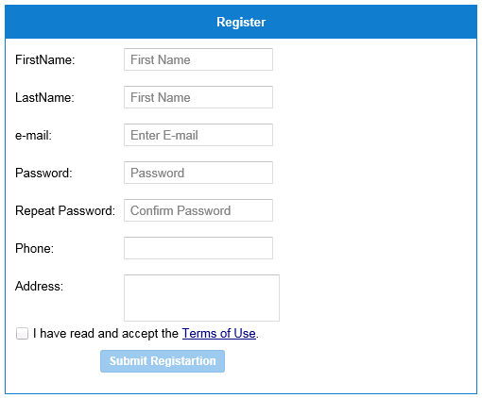

Login and User Details for registration

Figure 1.5: Registration page

Register Button—Confirmation button for unauthorized users to register his/her details.

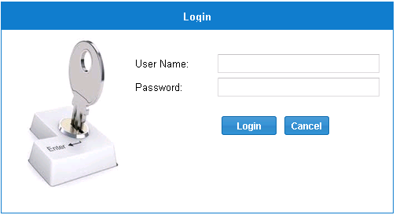

User credentials for sign in

Figure 1.6: Login Page

Sign in Button: Confirmation for the user to sign id to the e-Trademine web for views of trading details

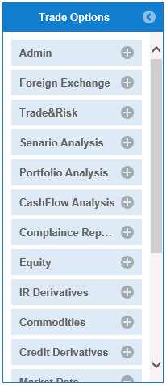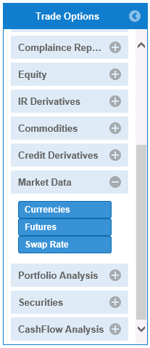Figure 1.7: Trade Options Slider

Trade Options Slider-- Different trading options for user to view

**Foreign Exchange (Forex/currency market):** The **Forex** is a form of transaction for the global decentralized trading of international currencies. Financial centers around the world function as anchors of trading between a wide range of different types of buyers and sellers across the world, with the exception of weekends. The foreign exchange market determines the relative values of different major currencies.

The foreign exchange market assists international trade and investment by enabling currency conversion. For example, it permits a business in the [United States](http://en.wikipedia.org/wiki/United_States) to import goods from the [European Union](http://en.wikipedia.org/wiki/European_Union) member states especially [Eurozone](http://en.wikipedia.org/wiki/Eurozone) members and pay [Euros](http://en.wikipedia.org/wiki/Euros), even though its income is in [United States dollars](http://en.wikipedia.org/wiki/United_States_dollar). It also supports direct speculation in the value of currencies, and the [carry trade](http://en.wikipedia.org/wiki/Carry_trade), speculation based on the interest rate differential between two currencies.

Almost every country, with some small exceptions, has its own currency and most of them can be traded. Known as the Majors - The big 5 currencies are the United States dollar (USD), Euro (EUR), Japanese yen (JPY), the British pound (GBP), and the Swiss franc (CHF). A 3-letter ISO (International Organization for Standardization) code is used for all currencies. Most often the 1st 2 letters designate the country, the 3rd designates the currency. Currencies are denoted by their standard symbols. Some of the commonly traded currencies and their symbols are USD, CHF, GBP, JPY, NZD, AUD, EUR, and CAD. G10 currencies are most liquid and actively traded.Non-G10 currencies are somewhat liquid and some of emerging market currencies are non-deliverable which cannot be traded in public exchange and they will be traded using NDF instruments.

**History of FOREX:**

Gold-Exchange Standard: Under this system, the value of all currencies was fixed in terms of how much gold for which they could be exchanged. For example, if one ounce of gold was worth 12 British pounds or 35 U.S. dollars, the exchange rate between dollars and pounds would remain constant at just under three to one. There were many advantages of the gold-exchange system:

* It served as a common measure of value
* It helped keep inflation in check by keeping money supply in the gold-exchange standard economies fairly stable

Long-term planning was easier as rate changes were infrequent. This system was put in place in 1944, when the leaders of allied nations met at Bretton Woods, New Hampshire, to set up a stable economic structure out of the chaos of World War II. The U.S. dollar was fixed at $35 per ounce of gold and all other currencies were expressed in terms of dollars. The Bretton Woods system began to weaken in the 1960s, when foreigners accumulated large amounts of U.S. dollars from post-World War II aid and sales of their exports in the United States.There were concerns as to whether the U.S. had enough gold to redeem all the dollars. With reserves of gold falling steadily, the situation could not be sustained and the U.S. decided to abandon this system. In 1971, President Nixon announced that U.S. dollars would no longer be convertible into gold.By 1973, this action led to the system of floating exchange rates that exist today. Currently, currencies rise and fall in value according to the forces of demand and supply. After the abandonment of the gold-exchange standard, the foreign exchange market went from a relatively unimportant financial specialty to the forefront of international economics. Foreign Exchange is the simultaneous Buying of one currency and Paying for it with another at an agreed price (exchange rate) for settlement on an agreed date. FOREX is an acronym for Foreign Exchange. Almost every country, with some small exceptions, has its own currency and most of them can be traded.

Fundamentals of Foreign Exchange Summary

* Exchange Rate is the number of units of a currency that are required to buy or sell one unit of base currency.
* It is the price of one currency expressed in terms of another currency. If Dollar to Yen exchange rate is 150, it means that 150 Yen are required to buy or sell one Dollar
* Exchange rate is simply the ratio of one currency valued against another currency.
* Pair/Currency Pair(ex:USD/JPY,USD/EUR)
* Currencies are always quoted in pairs.The first currency is known as Base currency in any currency pair. The second currency is called as Quote currency or Terms currency
* For example, if the USD/CHF rate equals 1.2345, then one USD is worth CHF 1.2345.
* Forex Quotations
* Currencies can be quoted in the following ways: Direct Quotation : $ 1 = Rs.43.64
* One unit of foreign currency = variable units of home currency Indirect Quotation : Rs.100 = 2.29 $
* Constant units of home currency = variable units of foreign currency Two-way quotes.( bid / offer ) : $/INR 43.64 - 43.65
* (More information on Two-way quotes in the next slide) Forex Quotations
* Two way Forex Quote
* When trading Forex you will often see a two-sided quote, consisting of a 'bid' and 'offer'.
* Remember: Bid and Offer are always quoted from the dealer's point of view. The 'bid' is the price at which the dealer will buy the base currency (at the same time selling the counter currency).
* The 'ask',also known as "offer" is the price at which the dealer will sell base currency (at the same time buying the counter currency).
* Forex Quotations Reading a Two-way Forex Quote Bid Offer
* A Forex deal takes place when two dealers from two different entities: agree to buy and sell two currencies at an agreed rate on an agreed value date.
* FX Trade Example
* FX Trade - Example Here is an example of how to calculate your profit or loss on a Forex trade: Let us do a trade wherein you buy Euros and sell US Dollars (USD). The exchange rate is 1.1700. You want to buy 10,000 Euros.
* This means you will sell 11,700 USD (10,000 X 1.17). [EUR 1 = USD 1.17] The objective of trading Forex is to exchange one currency for another with the expectation that the price will change and you get more value for the currency you bought or sold.
* One week later you decide to sell the 10,000 Euros and purchase USD. The exchange rate has changed to 1.2200. Now, you will sell 10,000 Euros, but as the exchange rate has moved up to 1.2200, you will receive (purchase) 12,200 USD.
* Remember for the same value of 10,000 Euros you sold 11,700 USD at a rate of 1.1700 and bought 12,200 USD at the rate of 1.2200. Hence you earn a profit of USD 500.
* In this section, we learnt about Foreign Exchange Quotations.
* The Exchange rates for trading are usually quoted as "two way prices" usually against the dollar.
* The left side of the quote is the Bid rate i.e. the price at which dealer (or whoever made the quote) is ready to Buy the Base currency.
* The right side of the quote is the Ask or Offer rate i.e. the price at which dealer (or whoever made the quote) is ready to sell the Base currency.
* The difference between the bid and offer price is known as Bid Offer margin or Spread.
* A Direct Quote gives the price of one unit of foreign currency (on the left side) in terms of variable units of home currency (on the right side).
* An Indirect Quote shows Constant units of home currency (on the left side) in terms of variable units of foreign currency (on the right side).
* We shall now cover few terms used in FX
* Currency Cut-off
* Cross Rate
* Cable day
* A cable day is the name given to the number of days before the value date that the payment will be released from the system which is used to process FX trades.
* For example - A deal is booked today and value tomorrow. The SWIFT message for the currency we are paying will need to be released today so that it arrives at our NOSTRO in time for the currency to be paid onwards to the beneficiary. In this example the currency has a cable day of '1'. (i.e.,The message must be released one day prior to the value date so that our NOSTRO has time to act on our instructions).
* Cut off time: A cut off time is the last time during any given day where payments can be made for value that day.
* For example. The cut off time for EUR payments is 3.45 UK time.
* If a request to make a payment is received after this time it may not be possible to credit the account on that day. JPMorgan New York have the EUR as a cable day of 1. Why? New York start at 2pm UK time (9am New York time) EUR cut off is 3pm UK time that would only leave 1 hour to process all the EUR payments and leaves very little time for any potential issues. By having a cable day of '1' most of the EUR payment messages are released the day before.
* These messages are then picked up at the start of day in Frankfurt and can be processed well before the cut off time.
* Spread - The difference between the sell quote and the buy quote.
* For example, if the quote for EUR/USD reads 1.3200/03, the spread is the difference between 1.3200 and 1.3203, or 3 pips.
* Pip - stands for "percentage in point" and is the fourth decimal point, which is 1/100th of 1%.
* For Example: In EUR/USD, a 3 pip spread is quoted as 1.2500/1.2503.
* Among the major currencies, the only exception to that rule is the Japanese yen. In USD/JPY, the quotation is only taken out to two decimal points (i.e. to 1/100 th of yen, as opposed to 1/1000th with other major currencies).
* In USD/JPY, a 3 pip spread is quoted as 114.05/114.08
* PIP: The smallest price increment in a currency, so instead of a point like in stocks, in the Forex market it is called a pip.
* Cross rate - is a currency pair that does not include USD, such as GBP/JPY. Pairs that involve the EUR are called euro crosses, such as EUR/GBP.
* All other currency pairs (those that don't involve USD or EUR) are generally referred to as cross rates.

Forex can be traded for any of the following types of transactions:

* FX Spot
* FX Forward
* FxFuture
* Non-deliverable Forward (NDF): Cash Settle Forward
* FX Option
* FX Swap

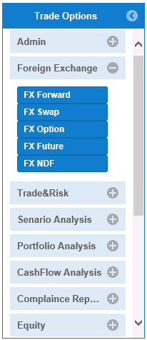

**Foreign Exchange:**The exchange of one currency for another, or the conversion of one currency into another currency. Foreign exchange also refers to the global market where currencies are traded virtually around-the-clock.

**Menu Options:** FxSpot/Forward, FxSwap, FxOption, FxFuture, FxNDF, TradeBlotter, RiskBlotter

Figure 1.8: Forex Options

**FxSpot/Forward Option:**A **Foreign Exchange spot** transaction, also known as **FX spot**, is an agreement between two parties to buy or sell a stated amount of a given currency at a specific price on an agreed price for settlement on the [spot date](http://en.wikipedia.org/wiki/Spot_date). If T is the trade date then spot transaction will settle on after 2 business days. V = T+2, where V is the value date or settlement date. And T stands for Trade date.

A **Foreign Exchange Forward** transaction, also known as **FX Forward** is an agreement between two parties to buy or sell a stated amount of a given currency at a specific price on an agreed date or range of dates in the future.If T is the trade date then spot transaction will settle on or after 3 business days. V = T + 3 or more, where V is the value date or settlement date. And T stands for Trade date Types of Foreign exchange trades FX Forward.

FX forwards help investors manage the risk inherent in currency markets by predetermining the rate and date on which they will purchase or sell a given amount of foreign exchange.

FxSpot/Forward inherits the Economic and Non-Economic details, cash-flow analysis, and fees details.

**Economic Details:** shows economic details such as currency pair, settlement date and forward/rate/strike/trade price based on currency pair.

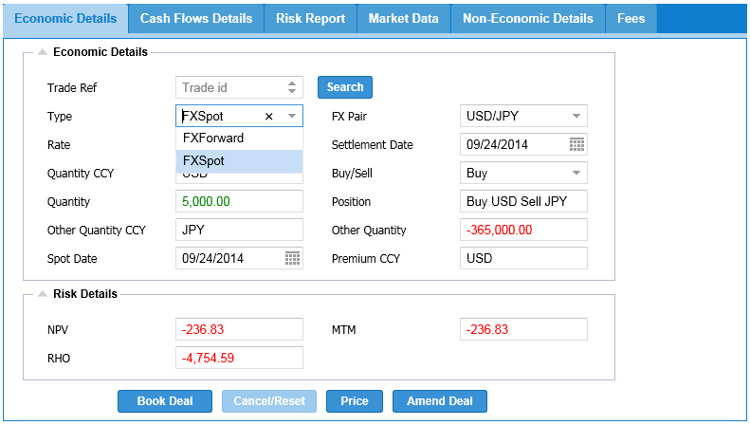

Figure 1.9: FxSpot/Forward—Economic Details

FxSpot/Forward: is a tab panel layout which offers different tabs of Economic and Non-Economic, Cashflow details.

Operations: save, cancel, price

Cancel button: is a button to delete the economic details from the trade blotter

Price button: is a button used to calculates the risk value for the data prompted by the user

Deal button: This button obtains in Economic Details such as currency pair, settlement date and forward/rate/strike/trade price based on currency pair and saves the data in trade blotter (highlighted in green color).

**Cash flow analysis:** shows the summary of overall between trade currencies with their projected future prices underlying expiration dates.

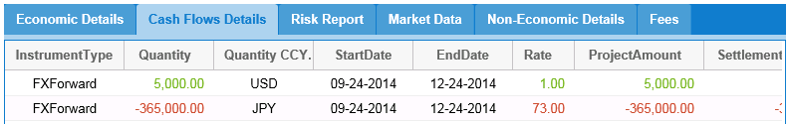

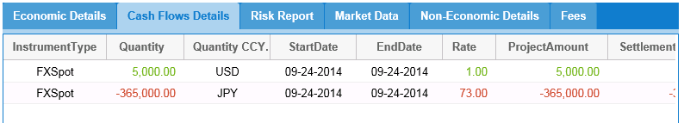

Figure 1.10: FxSpot/Forward—Cash Flow Details

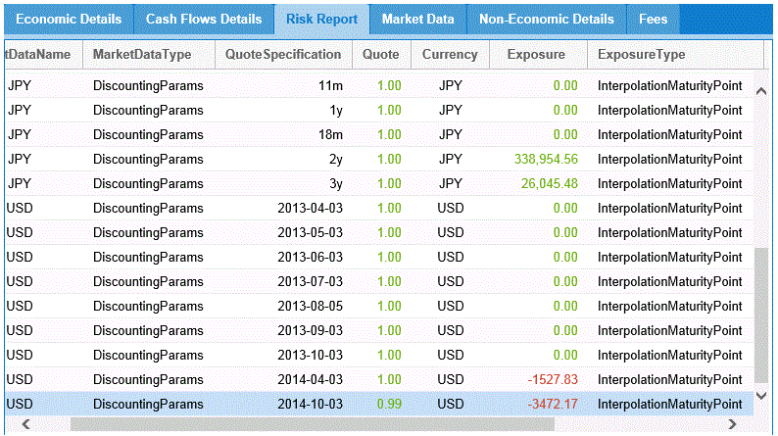

Figure 1.11: FxSpot/Forward—Risk Details

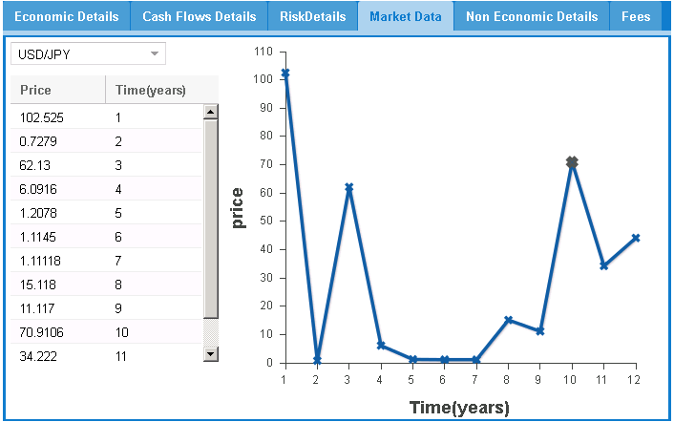

Figure 1.12: FxSpot/Forward—Market Data

**Non-Economic Details:** shows non-economic details based on user profiles.

Market value or P&L is calculated on market forward rate derived forward curve and trade price.

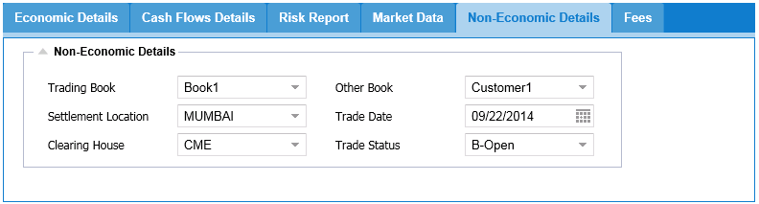

Figure 1.13: FxSpot/Forward--Non-Economic Details

**Fee Details:** User can select the broker based on the broker type the particular amount is fixed on the currency basis.

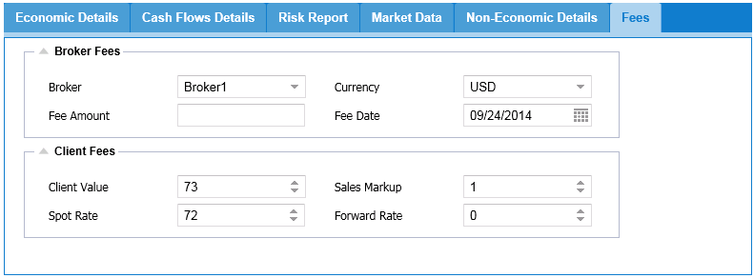

Figure 1.14: FxSpot/Forward--Fee Details

**FxSwap Option:**  A **Foreign Exchange Swap (Forex swap** or **FX swap)** is a simultaneous purchase and sale of identical amounts of one currency for another with two different value dates of spot to forward. An agreement between two parties to exchange cash flows based on two given underlying. Swap = FX Spot trade + Forward trade (where spot is traded and reversed in future).

Combination of a Spot trade and a Forward trade (where spot is traded and reversed in future) .Suppose a U.S. company needs 15 million Japanese yen for a three-month investment in Japan. It may agree to a rate of 150 yen to a dollar and swap $100,000 with a company willing to swap 15 million Japanese yen for three months. After three months, the U.S. Company returns the 15 million yen to the other company and gets back $100,000, with adjustments made for interest rate differentials.

Mismatch Swaps also supported where different nationals on each forward.

FxSwap inherits the Economic and Non-Economic details, cash-flow analysis.

**Economic Details:** shows economic details such as currency pair, settlement date and forward/rate/strike/trade price based on currency pair.

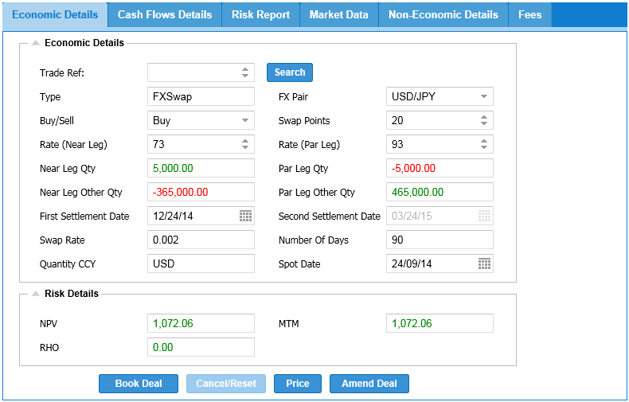

Figure 1.15: FxSwap—Economic Details

FxSwap: is a tab panel layout which offers different tabs of Economic and Non-Economic, Cashflow details, fees details.

Operations: save, cancel, price

Price button: is a button used to calculates the risk value for the data prompted by the user

Cancel button: is a button to delete the economic details from the trade blotter

Save button: This button obtains in Economic Details such as currency pair, settlement date and forward/rate/strike/trade price based on currency pair and saves the data in trade blotter (highlighted in green color).

**Cash flow analysis:** shows the summary of overall between trade currencies with their projected future prices underlying expiration dates.

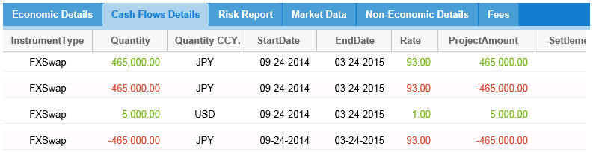

Figure 1.16: FxSwap—Cash Flow Details



Figure 1.17: FxSwap—Risk Details



Figure 1.18: FxSwap—Market Data

**Non-Economic Details:** shows non-economic details based on user profiles.



Figure 1.19: FxSwap—Non-Economic Details

**Fee Details:** User can select the broker based on the broker type the particular amount is fixed on the currency basis.

Market value or P&L is calculated on market forward rate derived forward curve and trade price.



Figure 1.20: FxSwap—Fees Details

**FxOption:** The foreign exchange options market is the deepest, largest and most liquid market for options of any kind. Most trading is over the Counter (OTC) and is lightly regulated, but a fraction is traded on exchanges like the International Securities Exchange, Philadelphia Stock Exchange, or the Chicago Mercantile Exchange for options on futures contracts. The global market for exchange-traded currency options was notionally valued by the Bank for International Settlements at $158.3 trillion in 2005

* An Option: Is a Derivative product in which the buyer has the right, but not the obligation to buy or sell the underlying product at an agreed price on an agreed date in the future. The buyer pays a premium to the seller to have this right.
* An FxOption: gives the Buyer of the Option the right, but NOT the obligation, to buy or sell a specific currency and amount at an agreed exchange rate at some time in the future. The agreed upon price is called the strike price.
* The Option contract buyer has 2 choices, between the option strike rate or the current market rate. Depending on which one is more favorable, the owner may exercise the option or let the option lapse, choosing instead to buy/sell currency in the market.

Suppose a trader purchases a three-month call on one million euros at 0.80 U.S. dollars to a euro. During the three months the trader can choose to either purchase one million euros at the strike rate of 0.80 OR purchase one million euros at the market rate Option can be bought or sold and on or before the expiration date.

FxOption inherits the Economic, Non-Economic, and Fees details.

**Economic Details:** shows economic details such as currency pair, settlement date and forward/rate/strike/trade price based on currency pair.

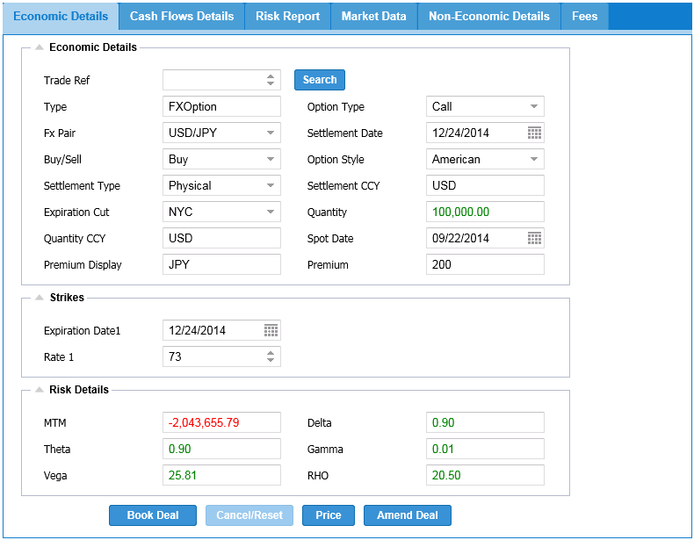

Figure 1.21: FxOption—Economic Details

FxOption: is a tab panel layout which offers different tabs of Economic, Non-Economic, and Fees details.

Operations: save, cancel, price

Cancel/Reset button: is a button to delete the economic details from the trade blotter

Price button: is a button used to calculates the risk value for the data prompted by the user

Book Deal button: This button obtains in Economic Details such as currency pair, settlement date and forward/rate/strike/trade price based on currency pair and saves the data in trade blotter (highlighted in green color).



Figure 1.22: FxOption—Risk Details

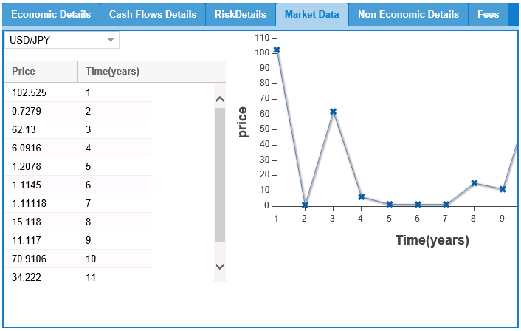

Figure 1.23: FxOption—Market Data

**Non-Economic Details:** shows non-economic details based on user profiles.



Figure 1.24: FxOption—Non-Economic Details

**Fee Details:** User can select the broker based on the broker type the particular amount is fixed on the currency basis.



Figure 1.25: FxOption—Fees Details

**FxFuture:** A **currency future**, also **FX future** or **foreign exchange future**, is a [futures contract](http://en.wikipedia.org/wiki/Futures_contract) to exchange one [currency](http://en.wikipedia.org/wiki/Currency) for another at a specified date in the future at a price ([exchange rate](http://en.wikipedia.org/wiki/Exchange_rate)) that is fixed on the purchase date.An exchange-traded contract to buy or sell a specified amount of a given currency at a predetermined price on a set date in the future. All Forex futures are written with a specific termination date, at which point delivery of the currency must occur unless an offsetting trade is made on the initial position.

An agreement between two parties to exchange cash flows based on two given underlying. Swap = FX Spot trade + Forward trade (where spot is traded and reversed in future).

Example of Swap :Combination of a Spot trade and a Forward trade (where spot is traded and reversed in future) .Suppose a U.S. company needs 15 million Japanese yen for a three-month investment in Japan. It may agree to a rate of 150 yen to a dollar and swap $100,000 with a company willing to swap 15 million Japanese yen for three months. After three months, the U.S. Company returns the 15 million yen to the other company and gets back $100,000, with adjustments made for interest rate differentials.

Mismatch Swaps also supported where different notional on each forward.

**Economic Details:** shows economic details such as currency pair, settlement date and forward/rate/strike/trade price based on currency pair.

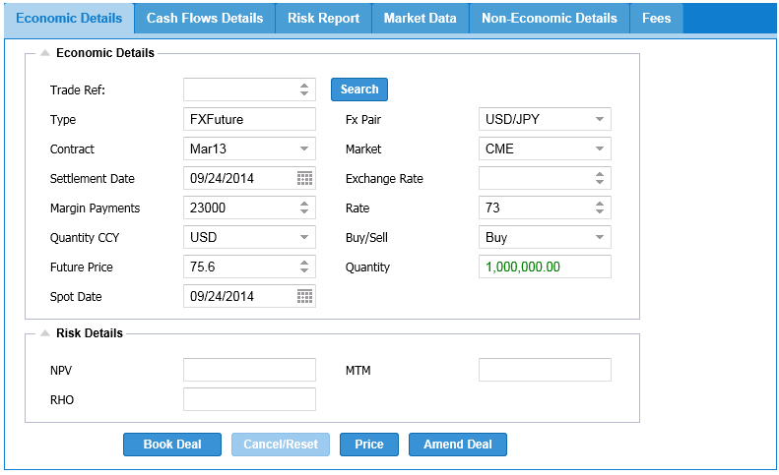

Figure 1.26: FxFuture—Economic Details

Price button: is a button used to calculates the risk value for the data prompted by the user

FxFuture: is a tab panel layout which offers different tabs of Economic and Non-Economic details.

Operations: save, cancel, price

Cancel button: is a button to delete the economic details from the trade blotter

Book Deal button: This button obtains in Economic Details such as currency pair, settlement date and forward/rate/strike/trade price based on currency pair and saves the data in trade blotter (highlighted in green color).

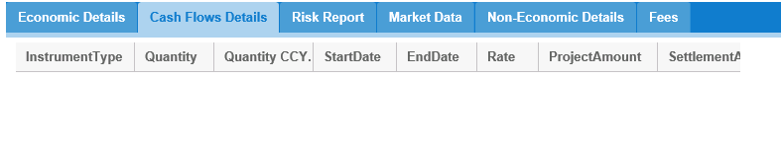

Figure 1.27: FxFuture—CashFlow Details



Figure 1.28: FxFuture—Risk Details

 Figure 1.29: FxFuture—Market Data

**Non-Economic Details:** shows non-economic details based on user profiles.



Figure 1.30: FxFuture—Non-Economic Details

**Fee Details:** User can select the broker based on the broker type the particular amount is fixed on the currency basis.

Market value or P&L is calculated on market forward rate derived forward curve and trade price.



Figure 1.31: FxFuture—Fees Details

**FxNDF Option:** A forward is a contract to buy or sell something at a certain future date at a certain price. A non-deliverable forward contract is a foreign currency financial derivative instrument.

NDF - NDFs are foreign exchange derivative products traded over the counter.

A NDF differs from a normal foreign currency forward contract in that there is no physical

Settlement of two currencies at maturity. It is a cash-settled outright forward.

**Key Features:**

* Notional - Notional amount is the 'face value' of the NDF which is agreed between the two counterparties.
* The NDF Rate - This is the rate agreed between the two counterparties on the transaction date.
* This is essentially the outright (or forward) rate of the currencies dealt. Every NDF has a fixing date and a settlement (delivery) date.
* Fixing Date: is the day and time whereby the comparison between the NDF rate and the prevailing spot rate is made.
* The settlement date: is the day whereby the difference is paid or received.
* A notional amount, forward exchange rate and forward date are all agreed at the deal's inception.
* There is no physical transfer of the principal amount in a NDF transaction.
* The deal is agreed on the basis of net settlement made in US$, or any other fully convertible currency, to reflect any differential between the agreed forward rate and the actual exchange rate on the agreed forward date.
* NDFs are commonly quoted for time periods of one month up to one year

**Why Trade NDF:**

* There are some currencies that cannot be physically delivered to the country of origin. Any profit or loss is cash-settled (payable) in USD (the deliverable currency). For e.g. BRL (non-deliverable) / USD (deliverable) Trading in NDF's is done to hedge exposure to foreign currencies that are not internationally traded.
* Local counter parry risk and the cost of holding accounts in local currencies (Nostro account) can be avoided.

**How is NDF settled?**

* **Th**e settlement exchange rate is determined by a daily-posted rate referred to as the "fixing rate" (usually posted to a specific Reuters or Telerate reference screen), with a fallback of calling leading dealers in the relevant market for a quote.
* The fixing rate is generally based on the spot rate traded for the onshore currency.
* Settlement is made in the major currency: paid to, or by, the customer, and reflects the differential between the agreed forward rate and the fixing spot rate.

**How Does NDF work?**

* An investor has invested US$2 million in stock on the Taiwanese stock market for one year. He expects the stock market to rise, but is worried about potential Taiwan dollar (T$) depreciation. He wishes to hedge his foreign exchange exposure using a NDF.
* A non-deliverable forward rate of T$35.80 per US dollar is agreed between the bank and the customer. The principal amount is US$2 million
* There are three possible outcomes in one year's time: the T$ has reached the forward rate, depreciated further or appreciated relative to the forward rate. Let us consider the three scenarios:
* Depreciated: 36.10
* Same : 35.80
* Appreciated :35.50
* There are three possible outcomes in one year's time: the T$ has reached the forward rate, depreciated further or appreciated relative to the forward rate.
* Let us consider the three scenarios:
* In all outcomes, the customer has achieved the objective of hedging the T$ exposure at 35.80.
* In Outcome A, the exchange loss that the customer would suffer if he sells his investment and exchanges the T$ proceeds in the spot market, is compensated by the proceeds of the NDF.
* In Outcome C, the customers exchange gain on realization of his investment is countered by the payment he makes on the NDF.

**Why use NDF:**

* Restricted local markets.
* Unrestricted trading hours.
* Settled in USD/deliverable currency.
* No need for local nostro account.
* Offshore credit risk.
* The demand for NDFs arises principally out of regulatory and liquidity issues in the underlying currency.

**Economic Details:** shows economic details such as currency pair, settlement date and forward/rate/strike/trade price based on currency pair.

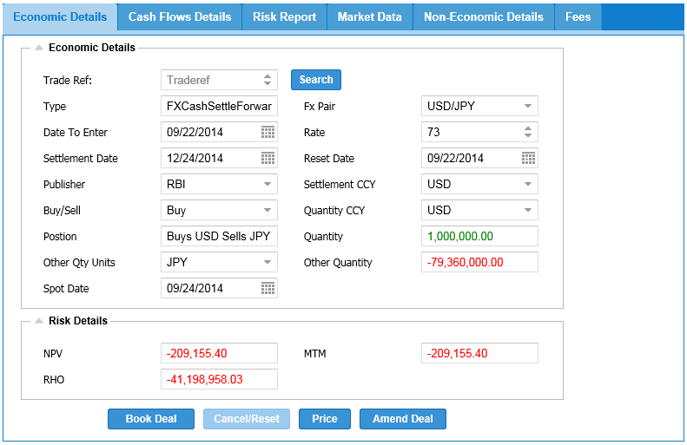

Figure 1.32: FxDNF—Economic Details

Price button: is a button used to calculates the risk value for the data prompted by the user

FxDNF option: is a tab panel layout which offers different tabs of Economic and Non-Economic details.

Operations: save, cancel, price

Cancel/Reset button: is a button to delete the economic details from the trade blotter

Book Deal button: This button obtains in Economic Details such as currency pair, settlement date and forward/rate/strike/trade price based on currency pair and saves the data in trade blotter (highlighted in green color).

**Cash flow analysis:** shows the summary of overall between trade currencies with their projected future prices underlying expiration dates.

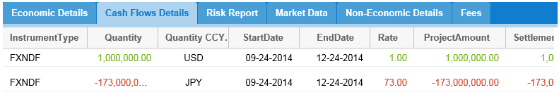

Figure 1.33: FxNDF—Cash Flow Details



Figure 1.34: FxNDF—Risk Details



Figure 1.35: FxNDF—Market Data

**Non-Economic Details:** shows non-economic details based on user profiles.



Figure 1.36: FxDNF—Non-Economic Details

**Fee Details:** User can select the broker based on the broker type the particular amount is fixed on the currency basis.



Figure 1.37: FxNDF—Fees Details

**Trade and Real-Time Analysis:**

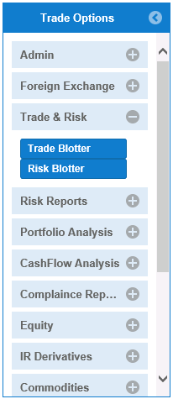

Figure 1.38: Trade and Risk Analysis Options

**Real-Time Trade Blotter Option:**A record of trades and the details of the trades made over a period of time (usually one trading day). The details of a trade will include such things as the time, price, order size and a specification of whether it was a buy or sell order. The blotter is usually created through a trading software program that records the trades made through a data feed.

The purpose of a trade blotter is to carefully document the trades so that they can be reviewed and confirmed by the trader or the brokerage firm. The blotter is used in the stock market, foreign exchange market, and the bond market and can be customized based on the needs of the user.

* Blotter will subscribe to real-time trade events
* Trade Blotter querying trades by
  + Portfolio,
  + Currency pair,
  + Trade currency,
  + Settlement and trade dates.

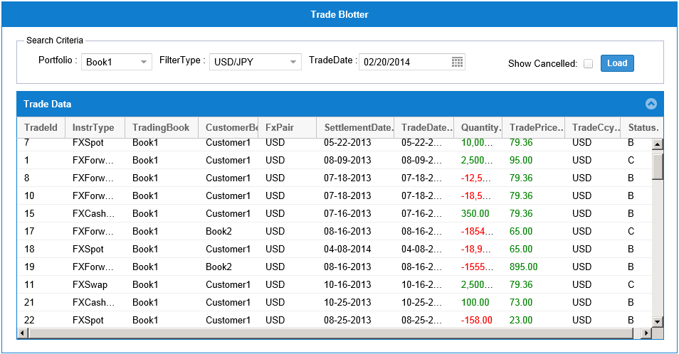

Figure 1.39: ForexTrade Blotter

Trade Blotter: This saves all Forex details and reflects the data using timer.

**TradeBlotter** allows user to monitor trade activity in real-time it shows historical and new trades

* Trade Id – Unique ID references confirmed trade
* Instrument Type – Instrument Type being traded i.e. FXSpot,FXForward,FXSwap,FXOption
* Trading Book – Trading Book associated with Client
* Customer Book – Opposite part name against whom client trade
* FXPair - Currency Pair associated with Instrument
* Settlement Date – Instrument SettlementDate
* Trade Date – Date when transaction is agreed between two parties
* Quantity - Asset Currency
* Trade Price – Trade price agreed between two parties
* Trade Ccy- Settlement Currency
* Status – Trade status such as Open,Approved,Cancel,Terminate or Dead

**Risk Blotter & Real Time Position:**The risk of an investment's value changing due to changes in currency exchange rates. The risk that an investor will have to close out a long or short position in a foreign currency at a loss due to an adverse movement in exchange rates. Also known as "currency risk" or "exchange-rate risk".

This risk usually affects businesses that export and/or import, but it can also affect investors making international investments. For example, if money must be converted to another currency to make a certain investment, then any changes in the currency exchange rate will cause that investment's value to either decrease or increase when the investment is sold and converted back into the original currency.

* Positions screen will reflect real-time trade activity
* FX Delta( 1% move in spot rate) will be calculated based on real-time positions and market data spot, forward and yield curves)
* Position Manager subscribe to real-time trade events and insert/amend the positions book and currency pair) also calculates realized P&L
* Liquidation Manager asynchronously generate cash flows based by portfolio and settlement date
* Real-time Risk Server calculates Unrealized, Realized P&L analysis, Cash balances

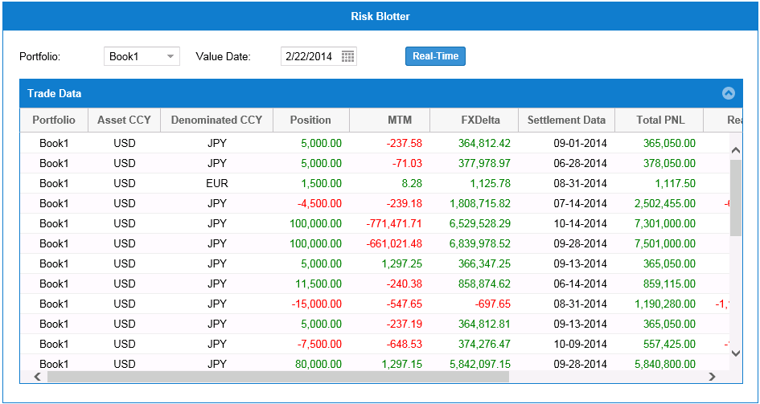

Figure 1.40: Forex Risk Blotter

Risk Blotter: This calculates the aggregation of currency pairs and instruments and runs risk values by using timer

RiskBlotter allows user to monitor risk in real-time.It uses Real-time market data and trade events to calculates risk

* Portfolio – Client book or account
* Asset CCY – Asset/Primary ccy
* Denominated CCY– Denominated/Quoting currency
* Position – Buy/Sell
* MTM – Mark to Market
* FX Delta – Change in MTM per unit currency
* Settlement Date – Instrument settlement Date
* Total PNL – Total P&L on this trade
* Realized – Realized P&L on this trade
* Un Realized – Unrealized P&L
* Cash – Cash flow received on this trade
* Instrument- FXSpot or Forward etc.,

**Risk Reports:**

Risk Analysis provides scenario analysis of trade by tweaking(shifting) the market data by different amounts.This helps user to assess the worst case scenario and hedge the risk associated it

Interest Rate Tweaks - This is gives bucketed risk values by tenor/period/date after bumping interest rate curve by tweaked amount

FX Tweaks – Calculates Bucketed Risk values by bumping FX Spot or Forward curve by tweaked amount

Gamma Interest Rate Tweaks – Change Delta for 1% move in spot for all tenors/period/dates for Interest Curve

Gamma FX Tweaks - Change Delta for 1% move in spot for all tenors/period/dates for Forward Curve

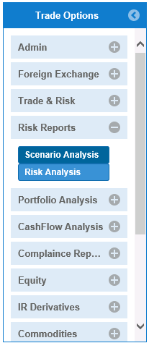

Figure 1.41: Risk Reports Options

**Scenario Analysis: Scenario analysis** is a process of analyzing possible future events by considering alternative possible outcomes (sometimes called "alternative worlds"). Thus, the scenario analysis, which is a main method of projections, does not try to show one exact picture of the future. Instead, it presents consciously several alternative future developments. Consequently, a scope of possible future outcomes is observable. Not only are the outcomes observable, also the development paths leading to the outcomes. In contrast to [prognoses](http://en.wikipedia.org/wiki/Prediction), the scenario analysis is not using [extrapolation](http://en.wikipedia.org/wiki/Extrapolation) of the past. It does not rely on historical data and does not expect past observations to be still valid in the future. Instead, it tries to consider possible developments and turning points, which may only be connected to the past. In short, several scenarios are demonstrated in a scenario analysis to show possible future outcomes. It is useful to generate a combination of an optimistic, a pessimistic, and a most likely scenario. Although highly discussed, experience has shown that around three scenarios are most appropriate for further discussion and selection. More scenarios could make the analysis unclear.

There are many different ways to approach scenario analysis, but a common method is to determine what the standard deviation of daily or monthly security returns are, and then compute what value would be expected for the portfolio if each security generated returns two or three standard deviations above and below the average return.

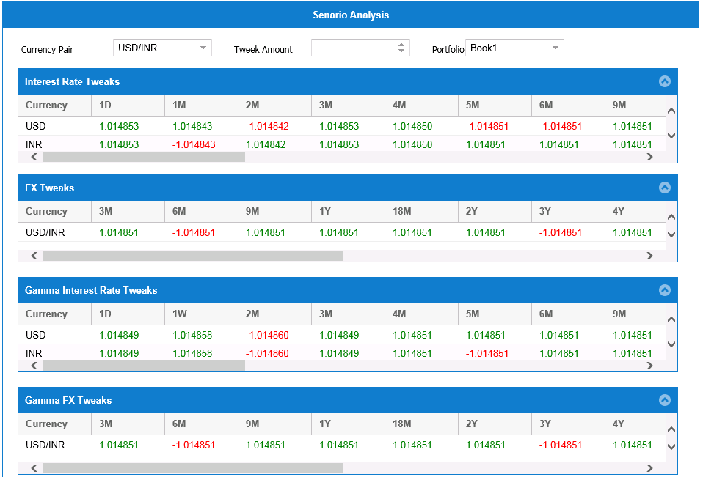

Figure 1.42: Scenario Analysis

**Portfolio Analysis:** Portfolio analysis is a study of the performance of specific portfolios under different circumstances. It includes the efforts made to achieve the best trade-off between risk tolerance and returns. The analysis of a portfolio can be conducted either by a professional or an individual investor.

Portfolio analysis involves quantifying the operational and financial impact of the portfolio. It is vital to evaluate the performances of investments and timing the returns effectively.

The analysis of a portfolio extends to all classes of investments such as bonds, equities, indexes, commodities, funds, options and securities. Portfolio analysis gains importance because each asset class has peculiar risk factors and returns associated with it. Hence, the composition of a portfolio affects the rate of return of the overall investment.

Portfolio analysis is broadly carried out for each asset at two levels:

Risk aversion: This method analyzes the portfolio composition while considering the risk appetite of an investor. Some investors may prefer to play safe and accept low profits rather than invest in risky assets that can generate high returns.

Analyzing returns: While performing portfolio analysis, prospective returns are calculated through the average and compound return methods. An average return is simply the arithmetic average of returns from individual assets. However, compound return is the arithmetic mean that considers the cumulative effect on overall returns.

The next step in portfolio analysis involves determining dispersion of returns. It is the measure of volatility or standard deviation of returns for a particular asset. Simply put, dispersion refers is the difference between the real interest rate and the calculated average return.

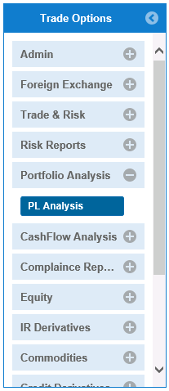

Figure 1.43: Portfolio Analysis Options

**Profit/Loss Analysis (P/L Analysis):** A financial statement that summarizes the revenues, costs and expenses incurred during a specific period of time - usually a fiscal quarter or year. These records provide information that shows the ability of a company to generate profit by increasing revenue and reducing costs. The P&L statement is also known as a "statement of profit and loss", an "income statement" or an "income and expense statement".

The statement of profit and loss follows a general form as seen in this example. It begins with an entry for revenue and subtracts from revenue the costs of running the business, including cost of goods sold, operating expenses, tax expense and interest expense. The bottom line (literally and figuratively) is net income (profit). Many templates can be found online for free, that can be used in creating your profit and loss, or income statement. The balance sheet, income statement and statement of cash flows are the most important financial statements produced by a company. While each is important in its own right, they are meant to be analyzed together.

Produce P&L for today for CDS, index CDS, CLN and bond trades MTD,QTD,YTD numbers for P&L,MTM,P&L explains using CR01,RR01,IR01 and Convexity P&L sign off workflow between FO traders and finance controllers

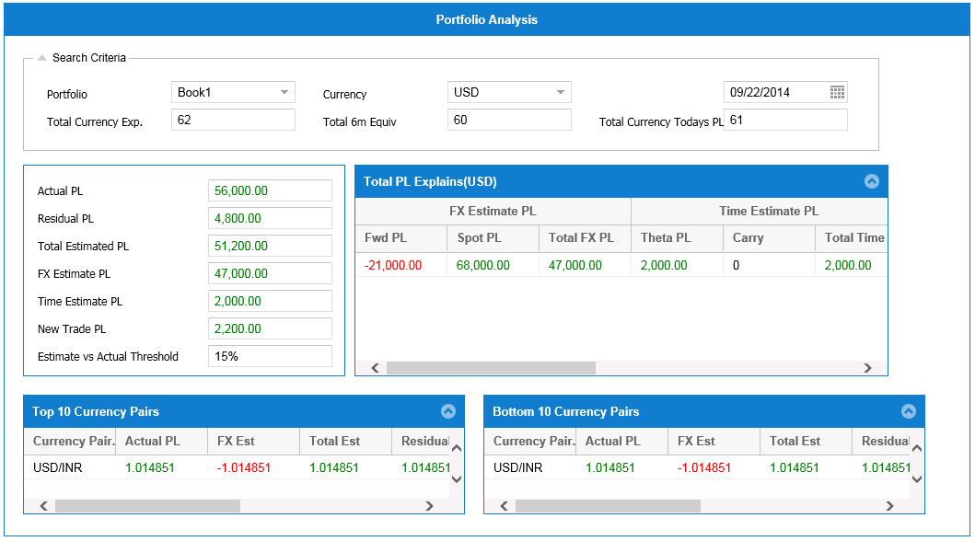

Figure 1.44: P/L Analysis

**Cash Flow Analysis:** A revenue or expense stream that changes a cash account over a given period.

Cash inflows usually arise from one of three activities - financing, operations or investing - although this also occurs as a result of donations or gifts in the case of personal finance.

Cash outflows result from expenses or investments. This holds true for both business and personal finance.

An accounting statement called the "statement of cash flows", which shows the amount of cash generated and used by a company in a given period. It is calculated by adding noncash charges (such as depreciation) to net income after taxes. Cash flow can be attributed to a specific project, or to a business as a whole. Cash flow can be used as an indication of a company's financial strength.

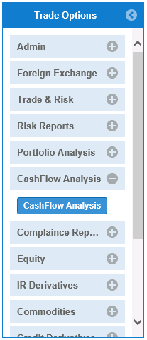

Figure 1.45: Cash Flow Analysis

Cash flow statements have three distinct sections, each of which relates to a particular component operations, investing and financing - of a company's business activities. For the less-experienced investor, making sense of a statement of cash flows is made easier by the use of literally-descriptive account captions and the standardization of the terminology and presentation formats used by all organizations:

Cash flow from operations, Cash flow from Investing, Cash flow from financing.

Cash flow to expenses or Cash flow to investments

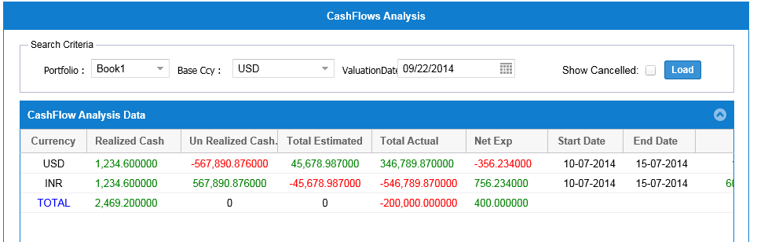

Figure 1.46: Cash Flow Analysis

**Compliance Reports:**

Our system can generate reports in line with Dodd Frank Act, Volcker Rule and Basel III.

* Covers Forward Value Adjustments, Credit charge (Credit Value Adjustment and Debit Value Adjustment)
* Volcker Rule reports - Inventory aging, Inventory turnover, Risk factor sensitivities, Risk and Position limits, Comprehensive P&L attribution, VaR and stress VaR and Customer facing trade ratio
* OIS and CSA Accounting standards

Our system can also be customized to be complied with law of land incase of any further requirements.

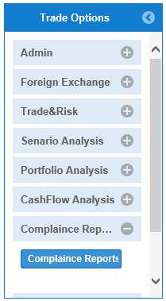

Figure 1.47: Compliance Report Options

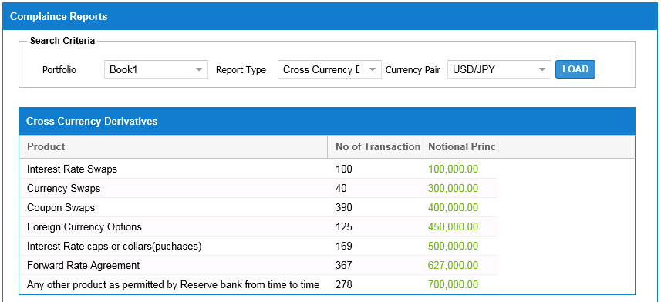

Figure 1.48: Compliance Reports

**Equities:** **Equity** means stock or any other security representing an ownership interest. Equity is the residual claim or interest of the most junior class of investors in [assets](http://en.wikipedia.org/wiki/Asset), after all [liabilities](http://en.wikipedia.org/wiki/Liabilities) are paid. If liability exceeds assets, [negative equity](http://en.wikipedia.org/wiki/Negative_equity) exists. In an accounting context, Shareholders' equity (or stockholders' equity, shareholders' funds, shareholders' capital or similar terms) represents the remaining interest in assets of a company, spread among individual [shareholders](http://en.wikipedia.org/wiki/Shareholder) of [common](http://en.wikipedia.org/wiki/Common_stock) or [preferred stock](http://en.wikipedia.org/wiki/Preferred_stock).

At the start of a [business](http://en.wikipedia.org/wiki/Business), [owners](http://en.wikipedia.org/wiki/Owner) put some funding into the business to finance [operations](http://en.wikipedia.org/wiki/Business_operations). This creates a liability on the business in the shape of [capital](http://en.wikipedia.org/wiki/Share_capital) as the business is a separate entity from its owners. Businesses can be considered, for [accounting](http://en.wikipedia.org/wiki/Accounting) purposes, sums of [liabilities](http://en.wikipedia.org/wiki/Liabilities) and [assets](http://en.wikipedia.org/wiki/Asset); this is the [accounting equation](http://en.wikipedia.org/wiki/Accounting_equation). After liabilities have been accounted for, the positive remainder is deemed the owner's interest in the business.

Different perspectives of equities:

* On a company's balance sheet, the amount of the funds contributed by the owners (the stockholders) plus the retained earnings (or losses). Also referred to as “shareholders equity”.
* In the context of margin trading, the value of securities in a margin account minus what has been borrowed from the brokerage.
* In the context of real estate, the difference between the current market value of the property and the amount the owner still owes on the mortgage. It is the amount that the owner would receive after selling a property and paying off the mortgage.
* In terms of investment strategies, equity (stocks) is one of the principal asset classes. The other two are fixed-income (bonds) and cash/cash-equivalents. These are used in asset allocation planning to structure a desired risk and return profile for an investor’s portfolio.

For example, a car or house with no outstanding debt is considered the owner's equity because he or she can readily sell the item for cash. Stocks are equity because they represent ownership in a company.

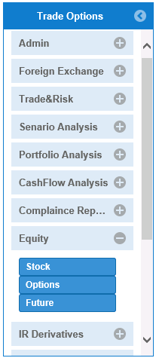

**Equities:** Trading Equity refers to the global stock shares performed by the owner of the shares or by the authorized agent to buy and sell on behalf of the shares owner.

**Menu Items:** Stocks, Option, Future

Figure 1.49: Equities Options

**Stocks**: The **stock** is an [incorporated business](http://en.wikipedia.org/wiki/Corporation) which integrates the [equity](http://en.wikipedia.org/wiki/Equity_(finance)) stake of its owners. It represents the residual assets of the organization that would be due to [stockholders](http://en.wikipedia.org/wiki/Stockholder) after discharge of all senior claims such as secured and unsecured debt i.e., lenders does/doesn’t have rights on the assets. Stockholders equity cannot be withdrawn from the company in a way that is intended to be damaging the company's creditors.

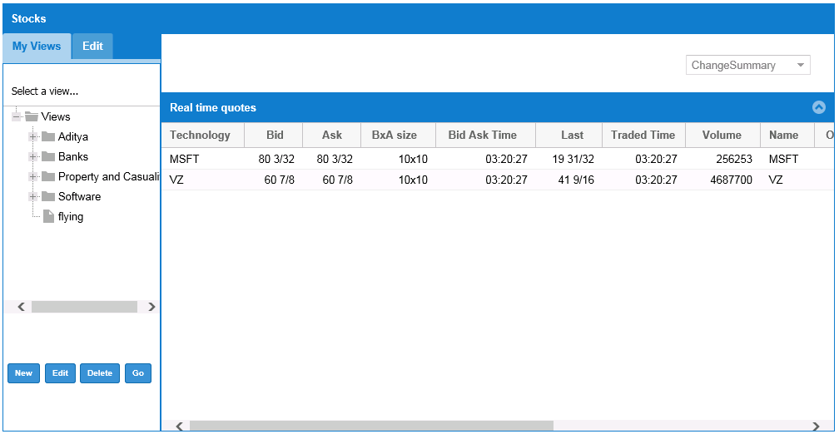

**Go button:** This searches for the key value i.e. symbol and shows the current trading data of an organization. This changes for every search operation.

Figure 1.50: Stocks View

**Options:** An **option** is a contract which gives the owner the right, but not the commitment or legal bound, to buy or sell an [underlying](http://en.wikipedia.org/wiki/Underlying) [asset](http://en.wikipedia.org/wiki/Asset) or [instrument](http://en.wikipedia.org/wiki/Financial_instrument) at a specified [strike price](http://en.wikipedia.org/wiki/Strike_price)on or before a specified [date](http://en.wikipedia.org/wiki/Expiration_(options)). The seller i.e. brokerage or third party incurs a corresponding commitment to fulfill the transaction, that is to sell or buy, if the long holder elects to "exercise" the option prior to expiration. The buyer pays a premium to the seller for this right. An option which conveys the right to buy something at a specific price is called a [**call**](http://en.wikipedia.org/wiki/Call_option); an option which conveys the right to sell something at a specific price is called a [**put**](http://en.wikipedia.org/wiki/Put_option). Both are commonly traded, though in basic equity for clarity the call option, as it moves in the same direction as the underlying asset, rather than opposite, as does the put.

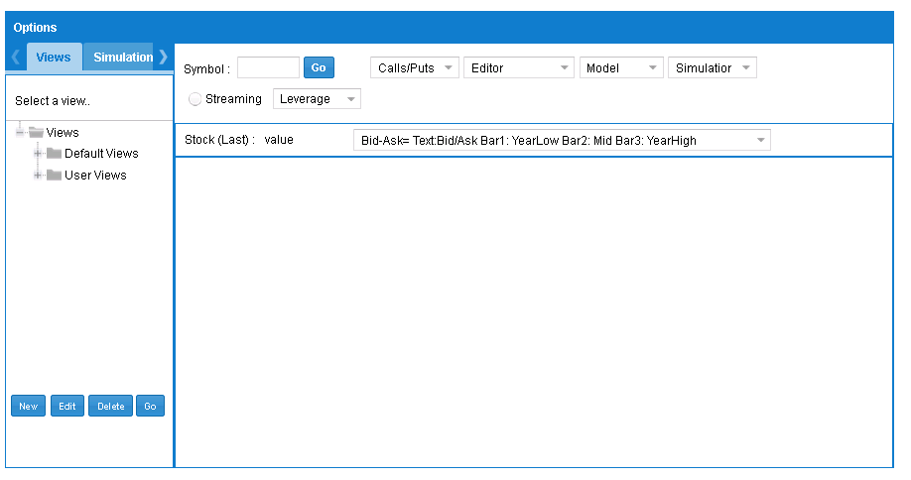

Figure 1.51: Options View

**Interest Rate Derivatives (IRDerivatives):**A financial instrument based on an underlying financial security whose value is affected by changes in interest rates. Interest-rate derivatives are hedges used by institutional investors such as banks to combat the changes in market interest rates. Individual investors are more likely to use interest-rate derivatives as a speculative tool - they hope to profit from their guesses about which direction market interest rates will move.

A plain vanilla interest-rate swap is the most basic type of interest-rate derivative. Under such an arrangement, there are two parties. Party one receives a stream of interest payments based on a floating interest rate and pays a stream of interest payments based on a fixed rate. Party two receives a stream of fixed interest rate payments and pays a stream of floating interest rate payments. Both streams of interest payments are based on the same amount of notional principal. Through this exchange, or swap, of cash flows, the two parties hope to reduce uncertainty and the threat of loss from changes in market interest rates. Other types of interest-rate derivatives include euro strips, swap options and interest rate call options.

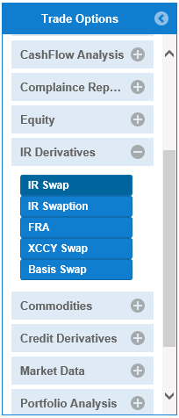

Figure 1.52: IR Derivatives Options

**IRSwap:** An investment tool whose payoff depends on the future level of interest rates. Interest rate options are both exchange traded and over-the-counter instruments.

Interest rate options from exchanges in the United States are offered on Treasury bond futures, Treasury note futures and euros, dollars futures. An investor taking a long position in interest rate call options believes that interest rates will rise, while an investor taking a position in interest rate put options believes that interest rates will fall.

Interest Rate Swaption are a form of Exchange Traded Derivative whose underlying value is the rate on various Financial Interest rates including treasury bills, and bonds. The exchange of these is monitored and facilitated by the CME Group. An Interest rate is similar to an equity option. There are two types, Calls and Puts. Calls give the bearer the right, but not the obligation, to benefit off a rise in interest rates. A put gives the bearer the right, but not the obligation, to profit off a decrease in interest rates.

All of these options are cash settled. A quantity of bonds does not have to be delivered, but the differences between the interest rates are settled using a scale of 100, much like equity options are. Interest Rate Swaption, however, differ from equity options in that excise in the European style. This allow the option to be excised only on a specified date and not at any point leading up to it.

Speculating on interest rates, or on any investment, is a risky strategy. Interest rate options should only be used by sophisticated investors with a high tolerance for risk.

The global market for exchange-traded interest rate options is notionally valued by the Bank for International Settlements at $3,075,400 million in 2005.

**Economic Details:** shows economic details such as currency pair, settlement date and forward/rate/strike/trade price based on currency pair.

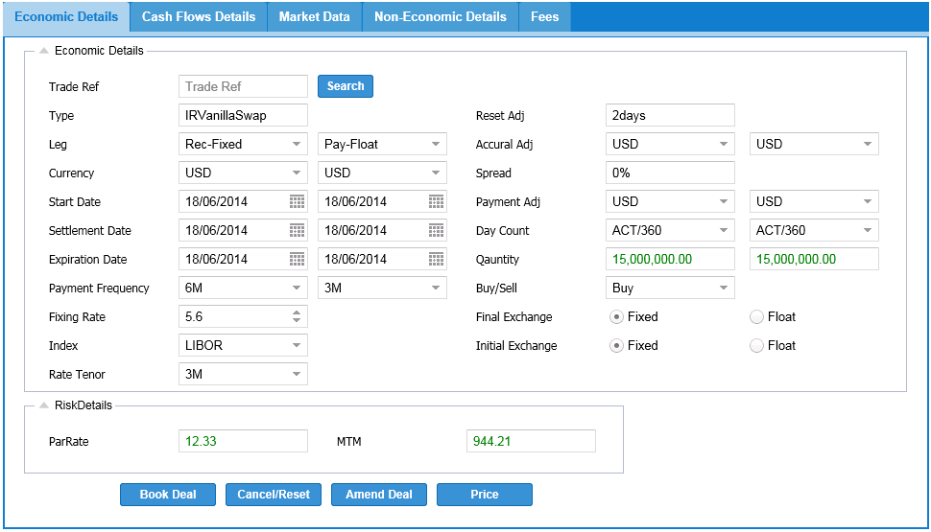Figure 1.53: IR Swap-Economic Details

IR Swap: is a tab panel layout which offers different tabs of Economic and Non-Economic details.

Operations: save, cancel, price

Price button: is a button used to calculates the risk value for the data prompted by the user

Cancel/Reset button: is a button to delete the economic details from the trade blotter

Book Deal button: This button obtains in Economic Details such as currency pair, settlement date and forward/rate/strike/trade price based on currency pair and saves the data in trade blotter (highlighted in green color).

**CashFlow Details:** shows Cashflow details such as instrument type, quantity, End date, start date, rate by implementing the pricing operation.

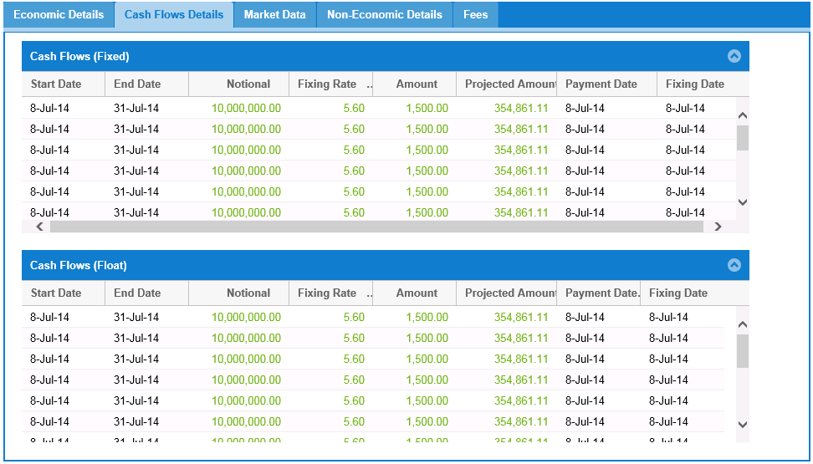

Figure 1.54: IR Swap-Cash Flow Details

**Non-Economic Details:** shows non-economic details based on user profiles.

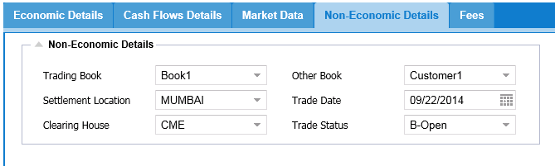Figure 1.55: IR Swap-Non Economic Details

**Fees Details:** gives price value of the broker fixed by the client at period of time.

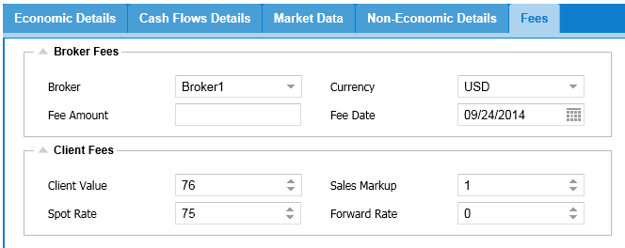

Figure 1.56: IR Swap-Fee Details

**IRSwaption:** An agreement between two parties (known as counterparties) where one stream of future interest payments is exchanged for another based on a specified principal amount. Interest rate swaps often exchange a fixed payment for a floating payment that is linked to an interest rate (most often the LIBOR). A company will typically use interest rate swaps to limit or manage exposure to fluctuations in interest rates, or to obtain a marginally lower interest rate than it would have been able to get without the swap.

Interest rate swaps are simply the exchange of one set of cash flows (based on interest rate specifications) for another. Because they trade OTC, they are really just contracts set up between two or more parties, and thus can be customized in any number of ways.

Generally speaking, swaps are sought by firms that desire a type of interest rate structure that another firm can provide less expensively. For example, let's say Cory's Tequila Company (CTC) is seeking to loan funds at a fixed interest rate, but Tom's Sports Inc. (TSI) has access to marginally cheaper fixed-rate funds. Tom's Sports can issue debt to investors at its low fixed rate and then trade the fixed-rate cash flow obligations to CTC for floating-rate obligations issued by TSI. Even though TSI may have a higher floating rate than CTC, by swapping the interest structures they are best able to obtain, their combined costs are decreased - a benefit that can be shared by both parties.

**Economic Details:** Economic Details gives the denominated currency, expiration dates by offering type IR Derivative.

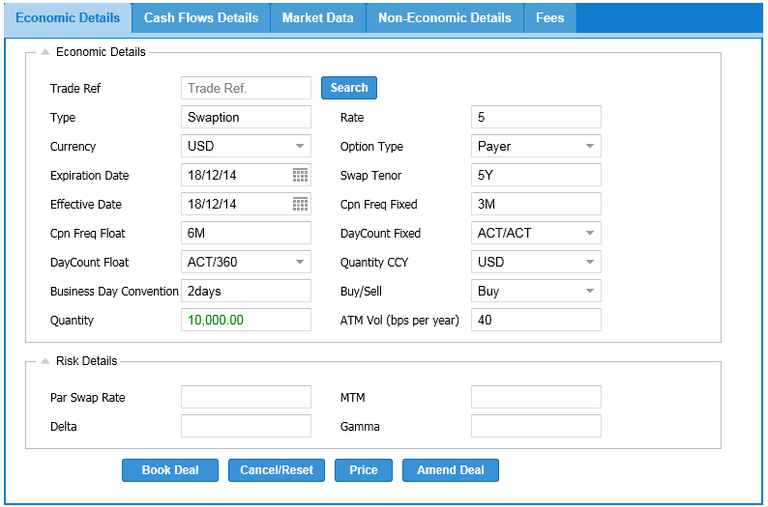

Figure 1.57: IR Swaption-Economic Details

IR Swap: is a tab panel layout which offers different tabs of Economic and Non-Economic details.

Operations: save, cancel, price

Price button: is a button used to calculates the risk value for the data prompted by the user

Cancel/Reset button: is a button to delete the economic details from the trade blotter

Book Deal button: This button obtains in Economic Details such as currency pair, settlement date and forward/rate/strike/trade price based on currency pair and saves the data in trade blotter (highlighted in green color).

**Non-Economic Details:** shows non-economic details based on user profiles.

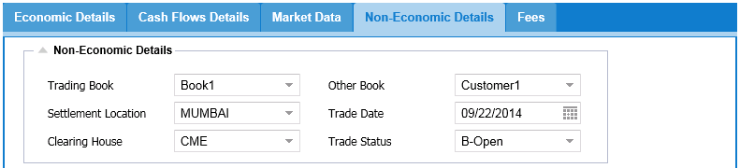

Figure 1.58: IR Swaption-Non Economic Details

**Fee Details:** User can select the broker based on the broker type the particular amount is fixed on the currency basis.

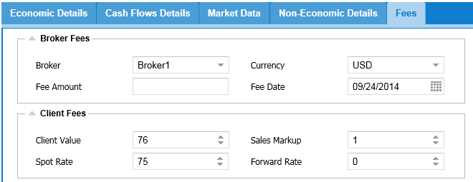

Figure 1.59: IR Swaption-Fee Details

**FRA (Forward Rate Agreement) Option:** A forward rate agreement (FRA) is a [forward contract](http://en.wikipedia.org/wiki/Forward_contract), which is contract between the two parties that determines the rate of interest, or the currency exchange rate, to be paid or received on an obligation before the future start date. The contract will determine the rates to be used along with the termination date and notional value. On this type of agreement, it is only the differential that is paid on the notional amount of the contract. It is paid on the effective date. The reference rate is fixed one or two days before the effective date, dependent on the market convention for the particular currency. FRAs are [over-the derivatives](http://en.wikipedia.org/wiki/Derivative_(finance)#OTC_and_exchange-traded). A FRA differs from a swap in that a payment is only made once at maturity.

Many banks and large corporations will use FRAs to hedge future interest or exchange rate exposure. The buyer hedges against the risk of rising interest rates, while the seller hedges against the risk of falling interest rates. Other parties that use FRAs are speculators purely looking to make bets on future directional changes in interest rates.

In other words, a forward rate agreement (FRA) is made over the counter financial futures contract on short-term deposits. A FRA transaction is a contract between two parties to exchange payments on a deposit, called the Notional amount, to be determined on the basis of a short-term interest rate, referred to as the Reference rate, over a predetermined time period at a future date. FRA transactions are entered as a hedge against interest rate changes. The buyer of the contract locks in the interest rate in an effort to protect against an interest rate increase, while the seller protects against a possible interest rate decline. At maturity, no funds exchange hands; rather, the difference between the contracted interest rate and the market rate is exchanged. The buyer of the contract is paid if the reference rate is above the contracted rate, and the buyer pays to the seller if the reference rate is below the contracted rate. A company that seeks to hedge against a possible increase in interest rates would purchase FRAs, whereas a company that seeks an interest hedge against a possible decline of the rates would sell FRAs.

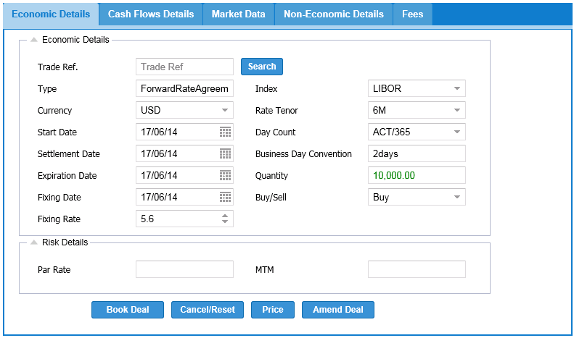

Figure 1.60: FRA-Economic Details

FRA: is a tab panel layout which offers different tabs of Economic and Non-Economic details.

Operations: save, cancel, price

Price button: is a button used to calculates the risk value for the data prompted by the user

Cancel/Reset button: is a button to delete the economic details from the trade blotter

Book Deal button: This button obtains in Economic Details such as currency pair, settlement date and forward/rate/strike/trade price based on currency pair and saves the data in trade blotter (highlighted in green color).

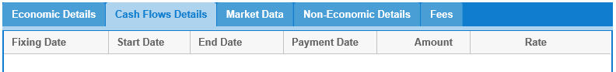

Figure 1.61: FRA-Cash Flow Details

**Non-Economic Details:** shows non-economic details based on user profiles.



Figure 1.62: FRA-Non Economic Details

**Fee Details:** User can select the broker based on the broker type the particular amount is fixed on the currency basis.



Figure 1.63: FRA-Fee Details

**Commodities:** Commodities markets, both historically and in modern times, have had tremendous economic impact on nations and people. The impact of commodity markets throughout history is still not fully known, but it has been suggested that rice futures may have been traded in China as far back as 6,000 years ago. Shortages on critical commodities have sparked wars throughout history (such as in World War II, when Japan ventured into foreign lands in order to secure oil and rubber), while oversupply can have a devastating impact on a region by devaluing the prices of core commodities.

Energy commodities such as crude are closely watched by countries, corporations and consumers alike. The average Western consumer can become significantly impacted by high crude prices. Alternatively, oil-producing countries in the Middle East (that are largely dependent on petrodollars as their source of income) can become adversely affected by low crude prices. Unusual disruptions caused by weather or natural disasters can not only be an impetus for price volatility, but can also cause regional food shortages. Read on to find out about the role that various commodities play in the global economy and how investors can turn economic events into opportunity.

The four categories of trading commodities include:

* 1. **Energy** (including crude oil, heating oil, natural gas and gasoline)
  2. **Metals** (including gold, silver, platinum and copper)
  3. **Livestock and Meat** (including lean hogs, pork bellies, live cattle and feeder cattle)
  4. **Agricultural** (including corn, soybeans, wheat, rice, cocoa, coffee, cotton and sugar)

Ancient civilizations traded a wide array of commodities, including livestock, seashells, spices and gold. Although the quality of product, date of delivery and transportation methods were often unreliable, commodity trading was an essential business. The might of empires can be viewed as somewhat proportionate to their ability to create and manage complex trading systems and facilitate commodity trades, as these served as the wheels of commerce economic development and taxation for the kingdom's treasuries. Reputation and reliability were critical underpinnings to secure the trust of ancient investors, traders and suppliers.

**Investment Characteristics:** Commodity trading in the exchanges can require agreed-upon standards so that trades can be executed (without visual inspection). You don't want to buy 100 units of cattle only to find out that the cattle are sick, or discover that the sugar purchased is of inferior or unacceptable quality.

There are other ways in which trading and investing in commodities can be very different from investing in traditional securities such as [stocks](http://www.investopedia.com/terms/s/stock.asp) and [bonds](http://www.investopedia.com/terms/b/bond.asp). Global economic development, technological advances and market demands for commodities influence the prices of staples such as oil, aluminum, copper, sugar and corn. For instance, the emergence of China and India as significant economic players has contributed to the declining availability of industrial metals, such as steel, for the rest of the globe.

Basic economic principles typically follow the commodities markets: lower [supply](http://www.investopedia.com/terms/s/supply.asp) equals higher prices. For instance, investors can follow livestock patterns and statistics. Major disruptions in supply, such as widespread health scares and diseases, can lead to investing [plays](http://www.investopedia.com/terms/p/play.asp), given that the long-term demand for livestock is generally stable and predictable

**The Gold Standard:** There is some call for caution, as investing directly in specific commodities can be a risky proposition, if not downright speculative without the requisite diligence and rationale involved. There are some plays that are more popular and sensible in nature. Volatile or [bearish](http://www.investopedia.com/terms/b/bear.asp) markets typically find scared investors scrambling to transfer money to precious metals such as gold, which has historically been viewed as a reliable, dependable metal with conveyable value. Investors losing money in the stock market can create nice returns by trading [precious metals](http://www.investopedia.com/terms/p/preciousmetal.asp). Precious metals can also be used as a hedge against high [inflation](http://www.investopedia.com/terms/i/inflation.asp) or periods of currency devaluation.

**Energizing the market:** Energy plays are also common for commodities. Global economic developments and reduction in oil outputs from wells around the world can lead to upward surges in oil prices, as investors weigh and assess limited oil supplies with ever-increasing energy demands. However, optimistic outlooks regarding the price of oil should be tempered with certain considerations. Economic downturns, production changes by the Organization of the Petroleum Exporting Countries (OPEC) and emerging technological advances (such as wind, solar and biofuel) that aim to supplant (or complement) crude oil as an energy purveyor should also be taken into consideration.

**Risky Business:** Commodities can quickly become risky [investment](http://www.investopedia.com/terms/i/investment.asp) propositions because they can be affected by eventualities that are difficult, if not impossible, to predict. These include unusual weather patterns, natural disasters, epidemics and man-made disasters. For example, grains have a very active trading market and can be volatile during summer months or periods of weather transitions. Therefore, it may be a good idea to not allocate more than 10% of a portfolio to commodities (unless there are genuine insights on specific trends or events).

**Exchanges:** With commodities playing a major and critical role in the global economic markets and affecting the lives of most of the people on the planet, there are multitudes of commodity and futures exchanges around the world. Each exchange carries a few commodities or specializes in a single commodity. For instance, the U.S. Futures Exchanges an important exchange that only carries energy commodities.

The most popular exchanges include the CME Group which resulted after the Chicago Mercantile Exchange and Chicago Board of Trade merged in 2006, Intercontinental Exchange, Kansas City Board of Trade and the London Metal Exchange.

**Futures and Hedging:** Futures, [forward contracts](http://www.investopedia.com/terms/f/forwardcontract.asp) and [hedging](http://www.investopedia.com/terms/h/hedge.asp) are a prevalent practice with commodities. The airline sector is an example of a large industry that must secure massive amounts of fuel at stable prices for planning purposes. Because of this need, airline companies engage in hedging and purchase fuel at fixed rates (for a period of time) in order to avoid the market volatility of crude and gasoline, which would make their financial statements more volatile, and riskier for investors. Farming cooperatives also utilize this mechanism. Without futures and hedging, volatility in commodities could cause [bankruptcies](http://www.investopedia.com/terms/b/bankruptcy.asp) for businesses that require predictability in managing their expenses. Thus, commodity exchanges are used by manufacturers and service providers as part of their budgeting process – and the ability to normalize expenses through the use of forward contracts reduces a lot of cash flow related headaches.

**The Bottom Line:** Investing in commodities can quickly degenerate into gambling or speculation when a trader makes uninformed decisions. However, by using commodity futures or hedging, investors and business planners can secure price insurance against volatile prices. Population growth, combined with limited agricultural supply, can provide opportunities to ride agricultural price increases. Demands for industrial metals can also lead to opportunities to make money by betting on future price increases. When markets are unusually volatile or bearish, commodities can also increase in price, and become a (temporary) place to park cash.

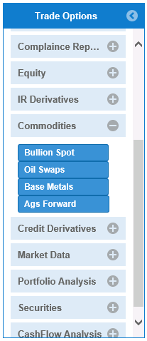

Figure 1.64: Commodities Options

**Credit Derivatives:** A credit derivative refers to any one of "various instruments and techniques designed to separate and then transfer the [*credit risk*](http://en.wikipedia.org/wiki/Credit_risk)" of the underlying loan. It is a [securitized](http://en.wikipedia.org/wiki/Securitization) [derivative](http://en.wikipedia.org/wiki/Derivative_(finance)) whereby the credit risk is transferred to an entity other than the lender.

Where credit protection is bought and sold between bilateral counterparties, this is known as an unfunded credit derivative. If the credit derivative is entered into by a financial institution or a [special purpose vehicle](http://en.wikipedia.org/wiki/Special_purpose_vehicle) (SPV) and payments under the credit derivative are funded using [securitization](http://en.wikipedia.org/wiki/Securitization) techniques, such that a debt obligation is issued by the financial institution or SPV to support these obligations, this is known as a funded credit derivative.

For example: A bank concerned that one of its customers may not be able to repay a loan can protect itself against loss by transferring the credit risk to another party while keeping the loan on its books.

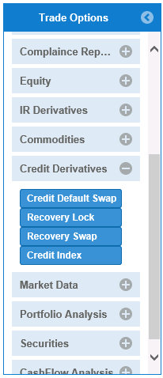

Figure 1.65: Credit Derivatives Options

**Credit Default Swap (CDS) Option:** A CDS is a [financial swap](http://en.wikipedia.org/wiki/Swap_(finance)) agreement that the seller of the CDS will compensate the buyer in the event of a loan [default](http://en.wikipedia.org/wiki/Default_(finance)) or other [credit event](http://en.wikipedia.org/wiki/Credit_event). The buyer of the CDS makes a series of payments to the seller in the form of fee and in exchange, receives a payoff if the loan defaults.

In the event of default the buyer of the CDS receives compensation (usually the [face value](http://en.wikipedia.org/wiki/Face_value) of the loan), and the seller of the CDS takes possession of the defaulted loan.[[1]](http://en.wikipedia.org/wiki/Credit_default_swap#cite_note-LBO_CDS-1) However, anyone can purchase a CDS, even buyers who do not hold the loan instrument and who have no direct [insurable interest](http://en.wikipedia.org/wiki/Insurable_interest) in the loan (these are called "naked" CDSs). If there are more CDS contracts outstanding than bonds in existence, a protocol exists to hold a [credit event auction](http://en.wikipedia.org/wiki/Credit_default_swap#Auctions); the payment received is usually substantially less than the face value of the loan.

For example, the buyer of a credit default swap will be entitled to the par value of the contract by the seller of the swap, should the third party default on payments. By purchasing a swap, the buyer is transferring the risk that a debt security will default.

**Market Data:** In [finance](http://en.wikipedia.org/wiki/Finance), market data is [quote](http://en.wikipedia.org/wiki/Financial_quote) and [trade](http://en.wikipedia.org/wiki/Trader_(finance))-related data associated with [equity](http://en.wikipedia.org/wiki/Stock), [fixed-income](http://en.wikipedia.org/wiki/Fixed_income), [financial derivatives](http://en.wikipedia.org/wiki/Financial_derivatives), [currency](http://en.wikipedia.org/wiki/Currency), and other investment [instruments](http://en.wikipedia.org/wiki/Financial_instrument). Market data is numerical price data, reported from trading venues, such as [stock exchanges](http://en.wikipedia.org/wiki/Stock_exchange). The price data is attached to a [ticker symbol](http://en.wikipedia.org/wiki/Ticker_symbol) and additional data about the trade. This price data is not only used in real time to make on-the-spot decisions about buying or selling, but historical market data (see graph at right) is also used to project pricing trends and to calculate market risk on portfolios of investments that may be held by an individual or an institutional investor.

Delivery of price data from exchanges to users, such as traders, is highly time-sensitive, approaching real-time. Specialized technologies called ticker plants are software (lately combined with [field programmable gate array processors](http://en.wikipedia.org/wiki/FPGA)), designed to handle collection and throughput of massive data streams, displaying prices for traders and feeding computerized trading systems fast enough to capture opportunities before markets change. When stored, historical market data is also called time-series data, because it requires a specialized type of database that enables retrieval of a series prices over time for a single instrument.

While market data generally refers to [real-time](http://en.wikipedia.org/wiki/Real_time_business_intelligence) or delayed price quotations, the term increasingly includes static or reference data—i.e. any type of data related to securities that is not changing in real-time. In other words, anything other than streaming prices.

Reference data includes identifier codes (e.g. [CUSIP](http://en.wikipedia.org/wiki/CUSIP)), the exchange a [security](http://en.wikipedia.org/wiki/Security_(finance)) trades on, end-of-day pricing, name and address of the issuing company, the terms of the security (such as interest rate and maturity on a bond), and the outstanding corporate actions (such as pending stock splits or proxy votes) related to the security. This type of data can be maintained in a relational database. Databases that maintain the references data for holdings in a portfolio are known as "securities master" files.

While price data generally originates from the exchanges, reference data generally originates from the issuer. However, before it arrives in the hands of investors or traders, it usually passes through the hands of [financial data vendors](http://en.wikipedia.org/wiki/Financial_data_vendor) or "aggregators" that may reformat it, organize it and attempt to clear obvious anomalies on a real-time basis. Today, the business of market data aggregation and reselling is changing rapidly, due to advances in communications in financial markets, as well as the technologies available to integrate multiple streams of inbound financial data.

For consumers of market data, which are primarily the financial institutions and industry utilities serving the capital markets realm, the complexity of managing market data has risen with the increasing numbers of issued securities and the globalization of capital markets. Beyond the rising volume of data, the continuing evolution of complex [derivatives](http://en.wikipedia.org/wiki/Derivative_(finance)) and indices, along with new regulations designed to contain risk and protect markets and investors, all create more operational demands on market data management.

There are various industry bodies that focus on Market Data:

* FISD, the Financial Information Services Division of the [Software and Information Industry Association](http://en.wikipedia.org/wiki/Software_and_Information_Industry_Association). Based in Washington DC FISD operates globally and consists of three constituency groups: Consumer Firms, Vendor Firms and Exchanges.
* IPUG, The Information Providers User Group, is a UK based organization whose membership is limited to Consumer Firms. Its main activities consist of lobbying Vendor Firms on key issues.

Cossiom, is the Paris based organization for French Consumer Firms.

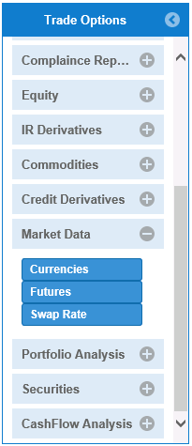

Figure 1.66: Market Data Options

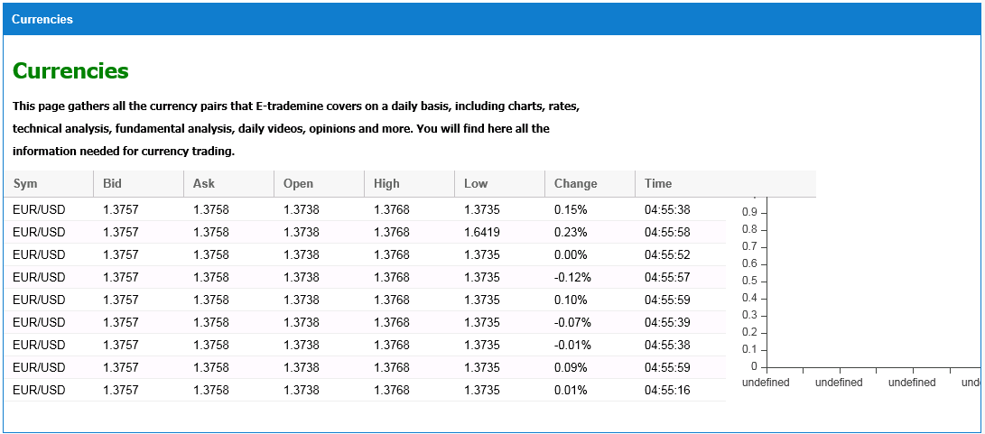

Figure 1.67: Summary of Currencies

**Securities:** Securities are broadly categorized into:

* [Debt](http://en.wikipedia.org/wiki/Debt) securities (such as [banknotes](http://en.wikipedia.org/wiki/Banknotes), [bonds](http://en.wikipedia.org/wiki/Bond_(finance)) and [debentures](http://en.wikipedia.org/wiki/Debenture))
* [Equity](http://en.wikipedia.org/wiki/Stock) securities, e.g., [common stocks](http://en.wikipedia.org/wiki/Common_stock) and
* [Derivative](http://en.wikipedia.org/wiki/Derivative_(finance)) contracts, such as [forwards](http://en.wikipedia.org/wiki/Forward_contract), [futures](http://en.wikipedia.org/wiki/Futures_contract), [options](http://en.wikipedia.org/wiki/Option_(finance)) and [swaps](http://en.wikipedia.org/wiki/Swap_(finance)).

The company or other entity issuing the security is called the [issuer](http://en.wikipedia.org/wiki/Issuer). A country's regulatory structure determines what qualifies as a security. For example, private investment pools may have some features of securities, but they may not be registered or regulated as such if they meet various restrictions.

Securities may be represented by a certificate or, more typically, "non-certificated", that is in electronic or "book entry" only form. Certificates may be *bearer*, meaning they entitle the holder to rights under the security merely by holding the security, or *registered*, meaning they entitle the holder to rights only if he appears on a security register maintained by the issuer or an intermediary. They include shares of corporate [stock](http://en.wikipedia.org/wiki/Stock) or [mutual funds](http://en.wikipedia.org/wiki/Mutual_fund), [bonds](http://en.wikipedia.org/wiki/Bond_(finance)) issued by corporations or governmental agencies, [stock options](http://en.wikipedia.org/wiki/Stock_option) or other options, limited partnership units, and various other formal investment instruments that are negotiable and fungible.

For example, the issuer of a bond issue may be a municipal government raising funds for a particular project. Investors of securities may be retail investors - those who buy and sell securities on their own behalf and not for an organization - and wholesale investors - financial institutions acting on behalf of clients or acting on their own account. Institutional investors include investment banks, pension funds, managed funds and insurance companies.

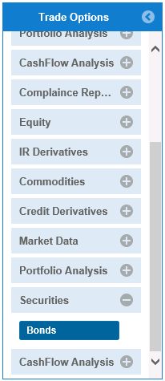

Figure 1.68: Commodities Options

**Bonds Option:** A **bond** is an instrument of indebtedness of the bond issuer to the holders. It is a debt [security](http://en.wikipedia.org/wiki/Security_(finance)), under which the issuer owes the holders a debt and, depending on the terms of the bond, is obliged to pay them [interest](http://en.wikipedia.org/wiki/Interest) (the [coupon](http://en.wikipedia.org/wiki/Coupon_(bond))) and/or to repay the principal at a later date, termed the [maturity](http://en.wikipedia.org/wiki/Maturity_(finance)). Interest is usually payable at fixed intervals (semiannual, annual and sometimes monthly). Very often the bond is negotiable, i.e. the ownership of the instrument can be transferred in the secondary market.

The *holder* of the bond is the lender (creditor), the *issuer* of the bond is the borrower (debtor), and the *coupon* is the interest. Bonds provide the borrower with external funds to finance long-term [investments](http://en.wikipedia.org/wiki/Investment), or, in the case of [government bonds](http://en.wikipedia.org/wiki/Government_bond), to finance current expenditure. [Certificates of deposit](http://en.wikipedia.org/wiki/Certificate_of_deposit) (CDs) or short term [commercial paper](http://en.wikipedia.org/wiki/Commercial_paper) are considered to be [money market](http://en.wikipedia.org/wiki/Money_market) instruments and not bonds: the main difference is in the length of the term of the instrument.

Bonds and [stocks](http://en.wikipedia.org/wiki/Stock) are both [securities](http://en.wikipedia.org/wiki/Security_(finance)), but the major difference between the two is that (capital) stockholders have an [equity](http://en.wikipedia.org/wiki/Equity_(finance)) stake in the company (i.e. they are owners), whereas bondholders have a creditor stake in the company (i.e. they are lenders). Another difference is that bonds usually have a defined term, or maturity, after which the bond is redeemed, whereas stocks may be outstanding indefinitely. An exception is an irredeemable bond, such as e, which is a [perpetuity](http://en.wikipedia.org/wiki/Perpetuity), i.e. a bond with no maturity.

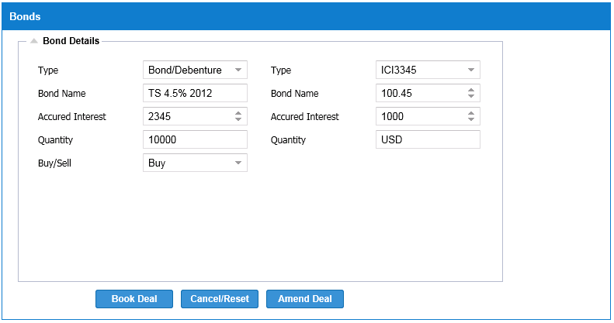

Figure 1.69: Bonds